Sentiment Analysis on Twitter Data Text Analytics Approach

Introduction
Microblogging websites tweeter have evolved to become a source of varied kind of information and playing an important role for sentiment analysis world-wide. According to statistics of twitter user (Twitter usage stats) more than 500 million tweets are tweeted everyday and this numbers are increasing . Analyzing tweets has applications in understanding how public sentiment is shaped, tracking public sentiment and polarization with respect to their views and issues and understanding the impact of tweets from various entities.
Organizations in entertainment area like movie producers ,game developers uses twitter data for sentiment analysis most to understand how the public feels about their product something at a particular moment in time, and also to track how those opinions change over time. Sentiment analysis helps them to take decision about their future projects. Now a days one challenge is to build technology to detect and summarize an overall sentiment.
In this project, we look at one such popular micro blog "Twitter" and do the sentiment analysis of Marvel Entertainment's (www.marvel.com) latest product Avenger age of ultron movie with a text analytics approach. We will look at public sentiment during the days leading up to and immediately following the recent release of the movie then analyze the twitter data sent from a specific geographic location (like Los Angels) then classify and visualize the results. It is expected that this analysis outcomes will help the organization to take the decision "making a sequel of this movie will be a massive block bluster" and help to predict how these sentiment data could used for better promote the next movie’s launch. This project will utilize state of the art big data tools and proven text analytics algorithms.

Dataset
This project will utilize the tweets produced by users of twitter from a specific geographic location . At present tweets are collected for the location Los Angels city, California state of USA and its 50 miles radius. At present stage, for the simplicity of the analysis we are considering 2000 tweets.
Tweets are collected using twitter API. The process of data collection is given below.

Twitter Authentification:

We can't directly pull tweets from the twitter. To do so twitter comes with OAuth handshake . It is necessary for every request we do, we have to verify our app.

First we need to create an app at Twitter. To do that we got to https://dev.twitter.com/ and log in with our Twitter Account. Then we created an application (Sentiment Analysis/mzkarim).

Clicking on Create we´ll get redirected to a screen with all the OAuth setting of our new App. The application authentication pages look like following .
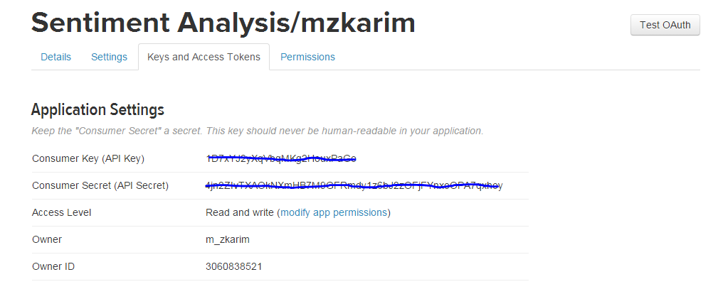
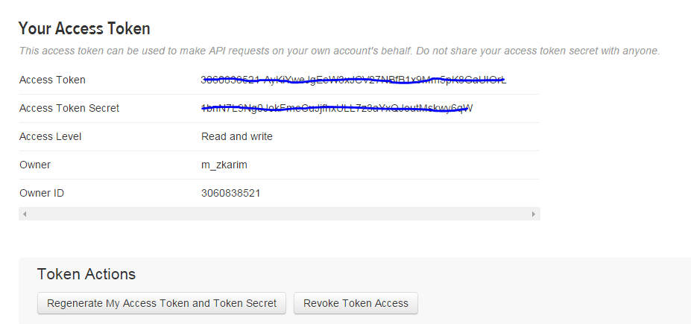
For data analysis we use R . Accessing twitter data in R requires to install some packages. First we installed these packages and then set up twitter api to work on r environment. To do so we need to write the following codes in R .
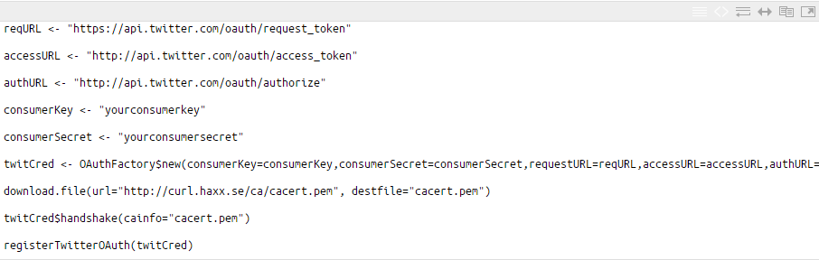

We have to replace "our consumerkey" and "our consumersecret" with the data provided on our app page on Twitter.

The command twitCred$handshake(cainfo=”cacert.pem”) will ask to go a certain URL and enter the PIN we receive on this page.
Collecting Twitter Data :

To get the tweets we use searchTwitter( ) function. The following code in R provides our required data :
tweets_geolocated = searchTwitter(' #AgeOfUltron', n=2000, lang="en", geocode="34.049933, -118.240843, 50mi")
This makes twitteR get 2000 Tweets with the keyword #AgeOfUltron with only English language in it. Geocode="34.049933, -118.240843,50mi " is for Los Angels, California with 50miles radius.

Approach
Our project involves the following approach ,

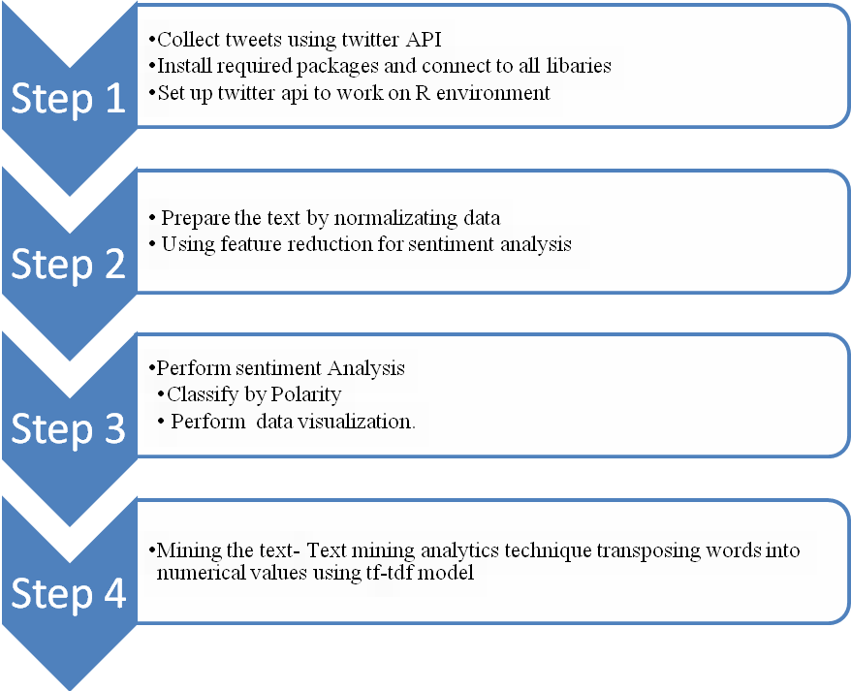
Step 1: Data Collect
Collect tweets from twitter related to "Avenger age of Ultron" movie. Install required packages in R and connect to all libraries. Set up Twitter API to work on R environment.
Step 2: Preprocessing extract text
Here, task is to convert all unstructured data into structured data by removing duplicate tweets, punctuation, unnecessary whitespace, non- english characters, irrelevant links.
Step 3: Perform Sentiment Analysis
Classify the text based on polarity. Learning method has been used here to classify the text. Separate the text by emotions and visualize the words with a comparison cloud. Eventually sentiment analysis speaks the overall contextual polarity of a document.
Step 4: Estimate Tweets sentiment
Get the score of negative and positive sentiment by performing “Sentiment scoring algorithm”. Here to get the result, “Breen’s Approach” has been considered. This method is called Lexicon which is nothing but word dictionary.
Step 5: Text mining
First, transforming text by building a corpus, that is a collection of text documents. Pre-processing text includes removing stopwords, changing letters to lower case, removing punctuations and numbers. After that, stemming words t retrieves the root from, so that words look normal. TermDocumentMatrix function provides the frequency of terms in document and also importance of the words by using performing findAssocs function.

